**Lab1:**

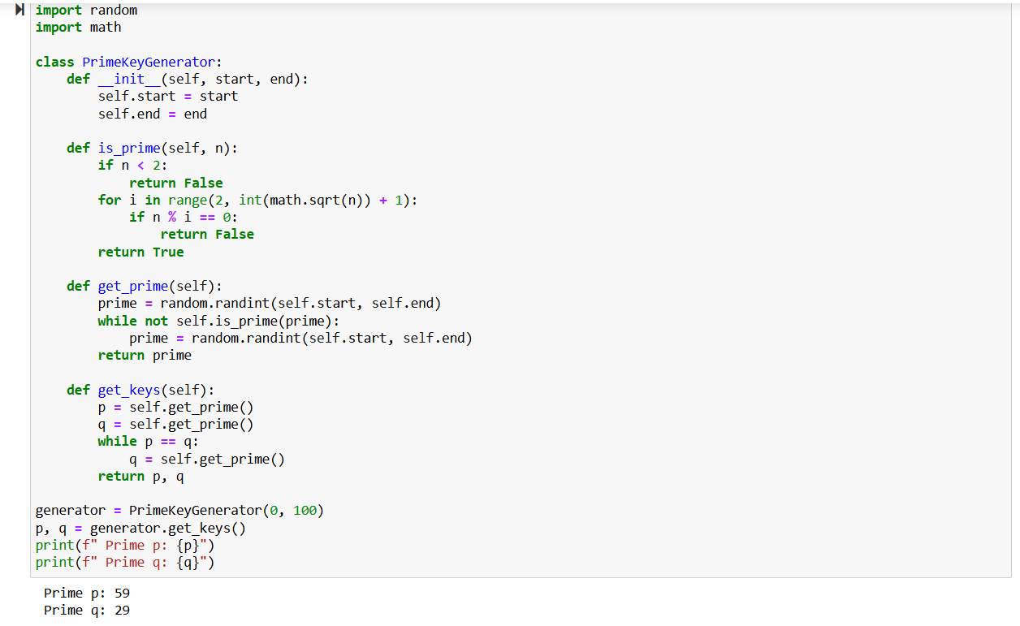

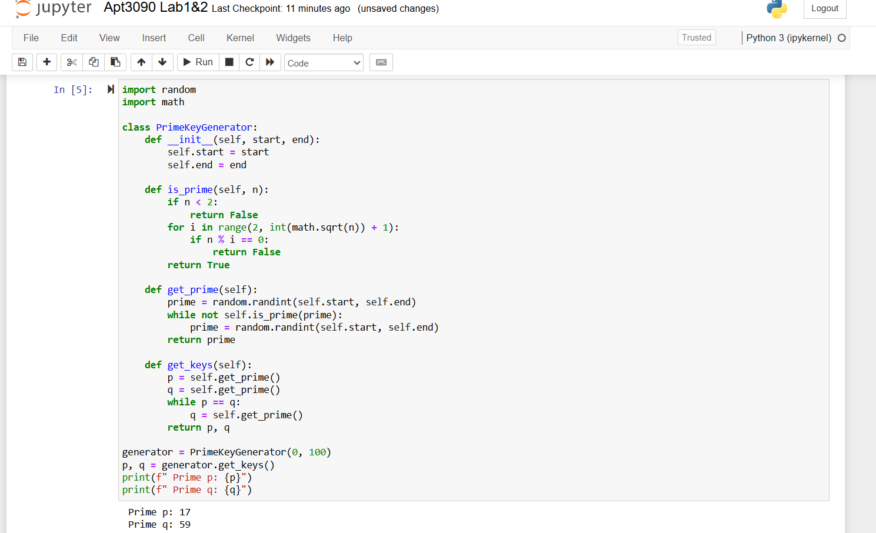

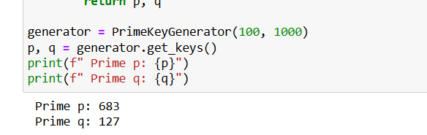

**Lab2:**

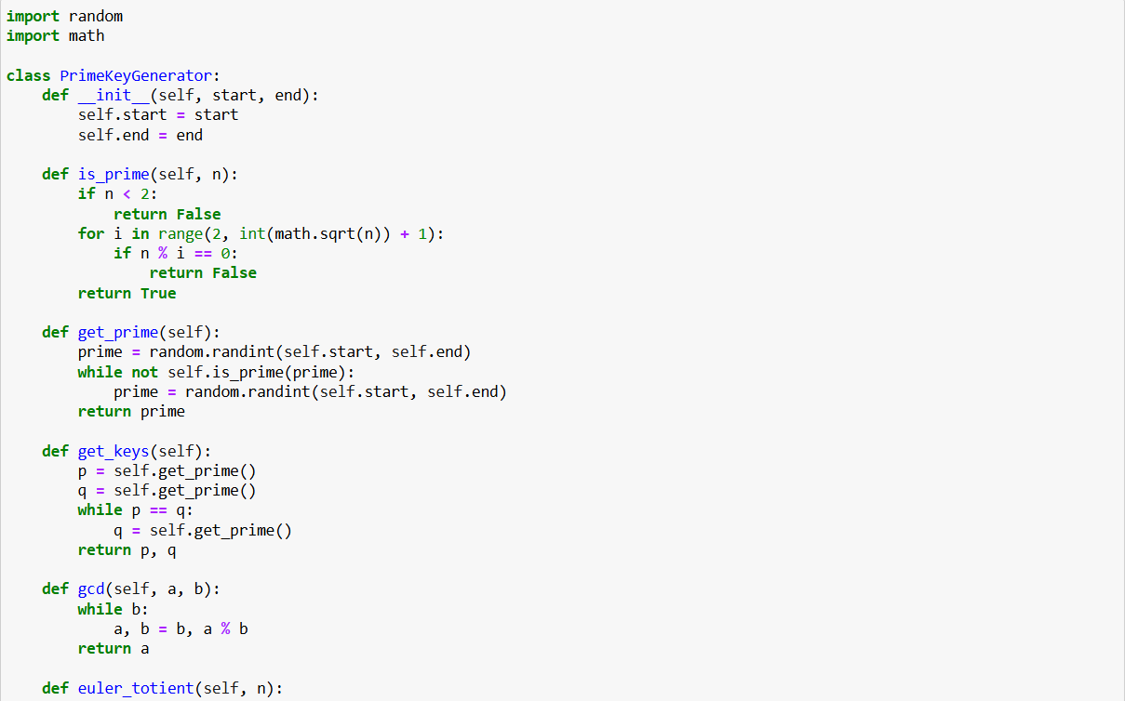

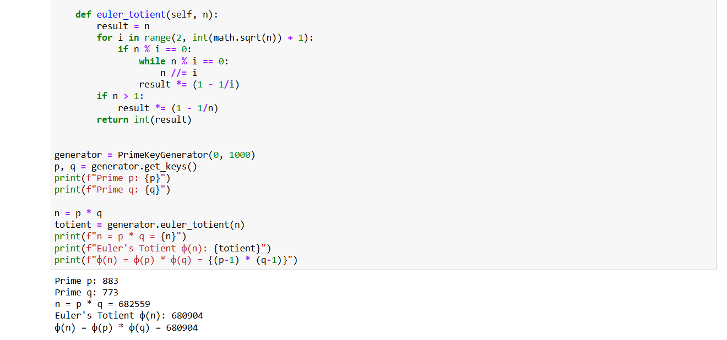

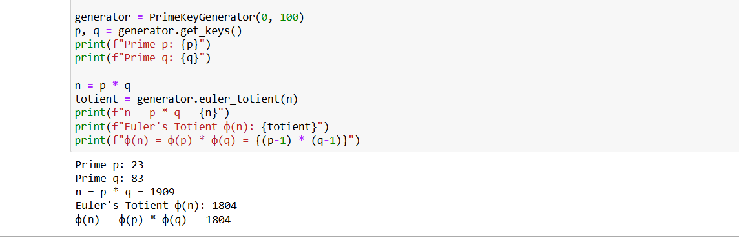

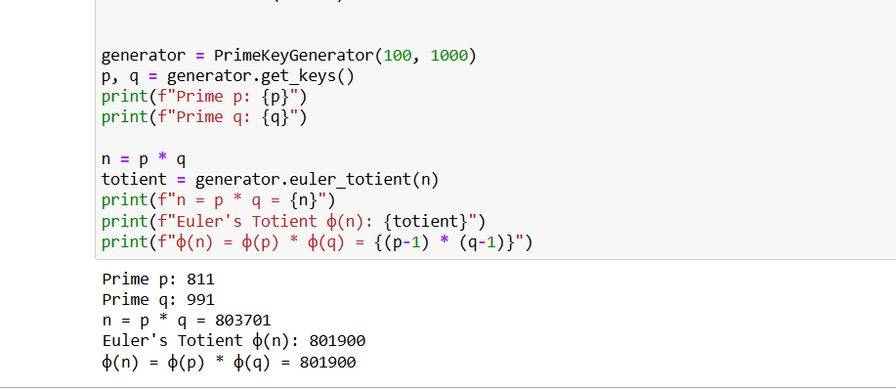

**Explanation of the algorithms**

In Lab1, we generate two random prime numbers, p and q, within a given range. We use trial division up to the square root of the number to check if a number is prime. Finally, we make sure that p and q are distinct primes.

For Lab2, the code generates random primes p and q and then calculates Φ(n) where n = p * q. The euler_totient() method calculates the Euler Totient function for the product of p and q. The code also demonstrates that Φ(n) = Φ(p) * Φ(q) = (p-1) * (q-1) for two distinct primes. The code satisfies the requirement as it is able to randomly generate prime numbers and calculate Euler’s Totient function values correctly.